BUMES Operation Guide & Supporting Documentation

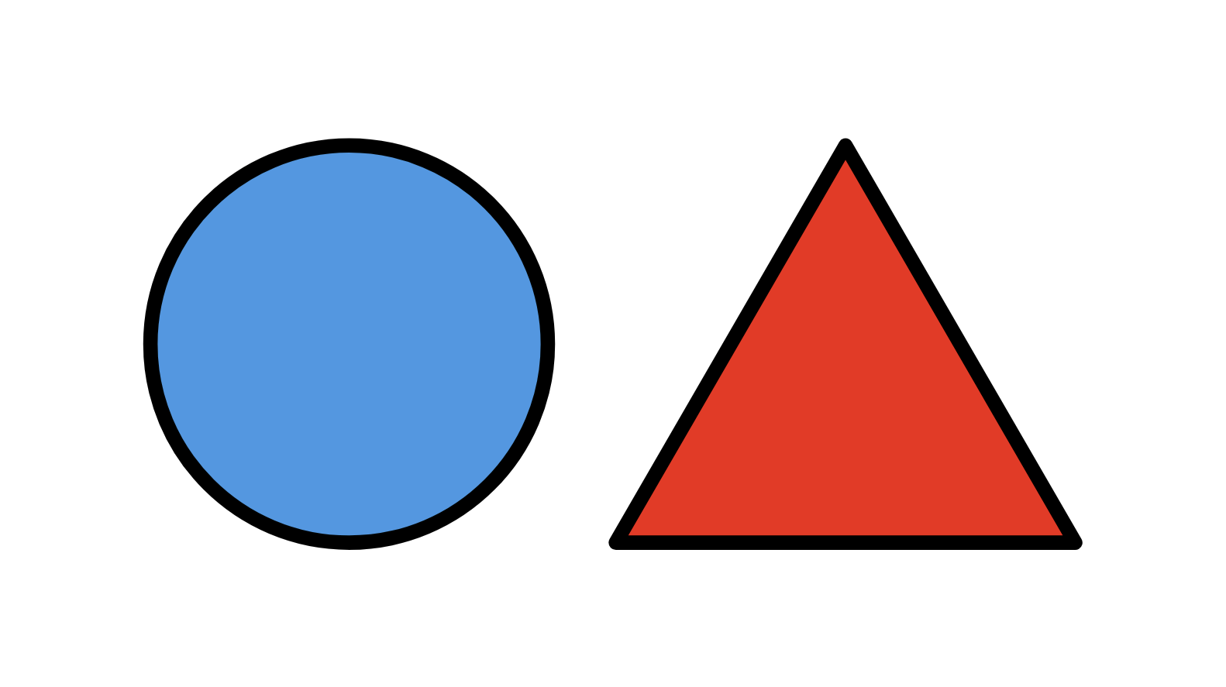

ME500: Advanced Manufacturing
Spring 2026
Variable Product Manufacturing (Thursday PM Lab Group)
Chris Daub, Riley Hubscher, Mukhamed Kerimkul, Bramasto Prasojo, and Chaitanya Sai Nikith Rambha

Table of Contents
Overview 3
Operation Guide 3
BUMES System Flow 4
Appendix A: BUMES Script Descriptions 5
ShortLid: 5
ShortBody: 5
TallLid: 5
TallBody: 6
Appendix B: BUMES Script Plaintext 7
ShortLid 7
ShortBody 10
TallLid 13
TallBody 16

Overview
This document serves as the operation guide and supporting documentation for the Variable Product Manufacturing system (VPM). This guide provides step-by-step operating instructions, a system flow diagram, and full plaintext listings of the four BUMES control scripts (ShortLid, ShortBody, TallLid, and TallBody) that orchestrate the manufacturing process. All files have been submitted to Blackboard in a ZIP file with this document.

Operation Guide
To operate the variable product manufacturing system, follow the listed steps in the ADML:
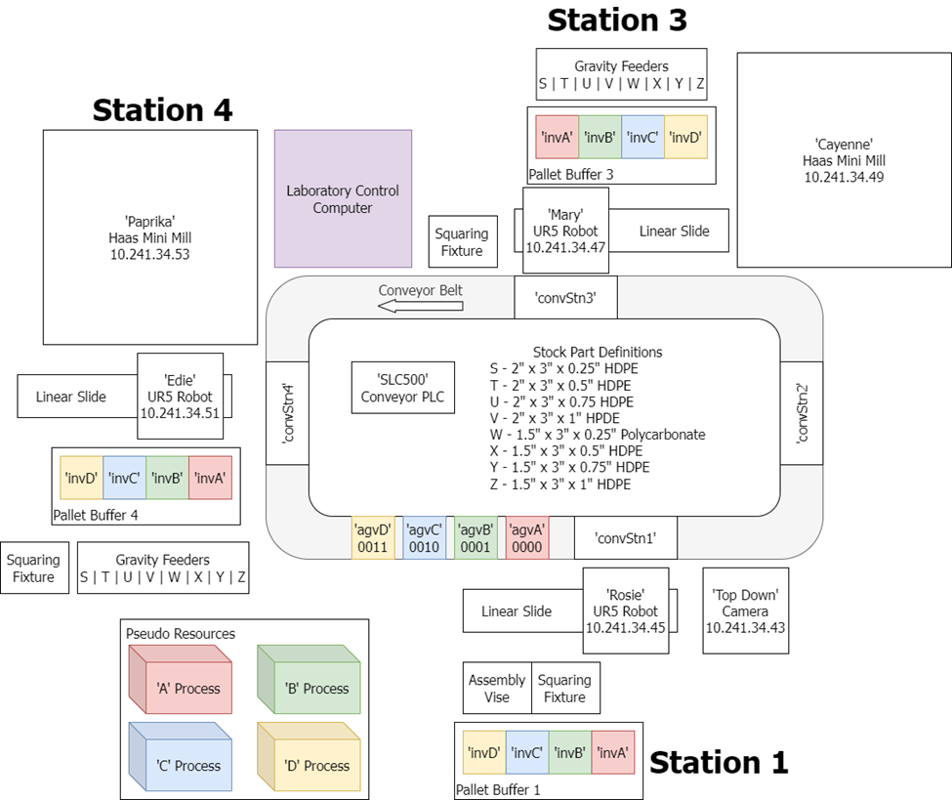
- Turn on all machines in the ADML, including robots, CNC mills, conveyor belt, and master air supply to the room. Further instructions on this may be found in the respective mills for each machine. Ensure that the computer vision webcam is connected to BUMES Computer 1
- Populate the pallet inventory bays by Rosie with pallets set for stock sizes T and V using 3D printed pegs
- Prepare the robots for BUMES by clicking “Run Program” on the touchscreen
- Prepare the CNC mills for BUMES by selecting program 9000 from the onboard memory. Clear any errors with the Reset key and then press “Power up/Restart”. Repeat this process if the mills fall asleep at any point
- Fill gravity feeders with stocks T and V
- Initialize BUMES on BUMES Computer 1
- On the same computer, initialize the vision software by opening the provided programs listener_server.py, modbus_server.py, vision.py, vision_utils.py, and vision_extras.py. Their connections to BUMES are described in the computer vision and integration scripts manual
- Queue and run all of the following BUMES programs:
- ShortLid
- ShortBody
- TallLid
- TallBody
- Supervise all machines to ensure that no crashes, drops, or other failures occur. After product is delivered to the inventory bin, safely remove the product
- Power off all machines as described in their respective manuals. Return pallets to their respective storage locations.

BUMES System Flow
The BUMES system flow is the depicted below: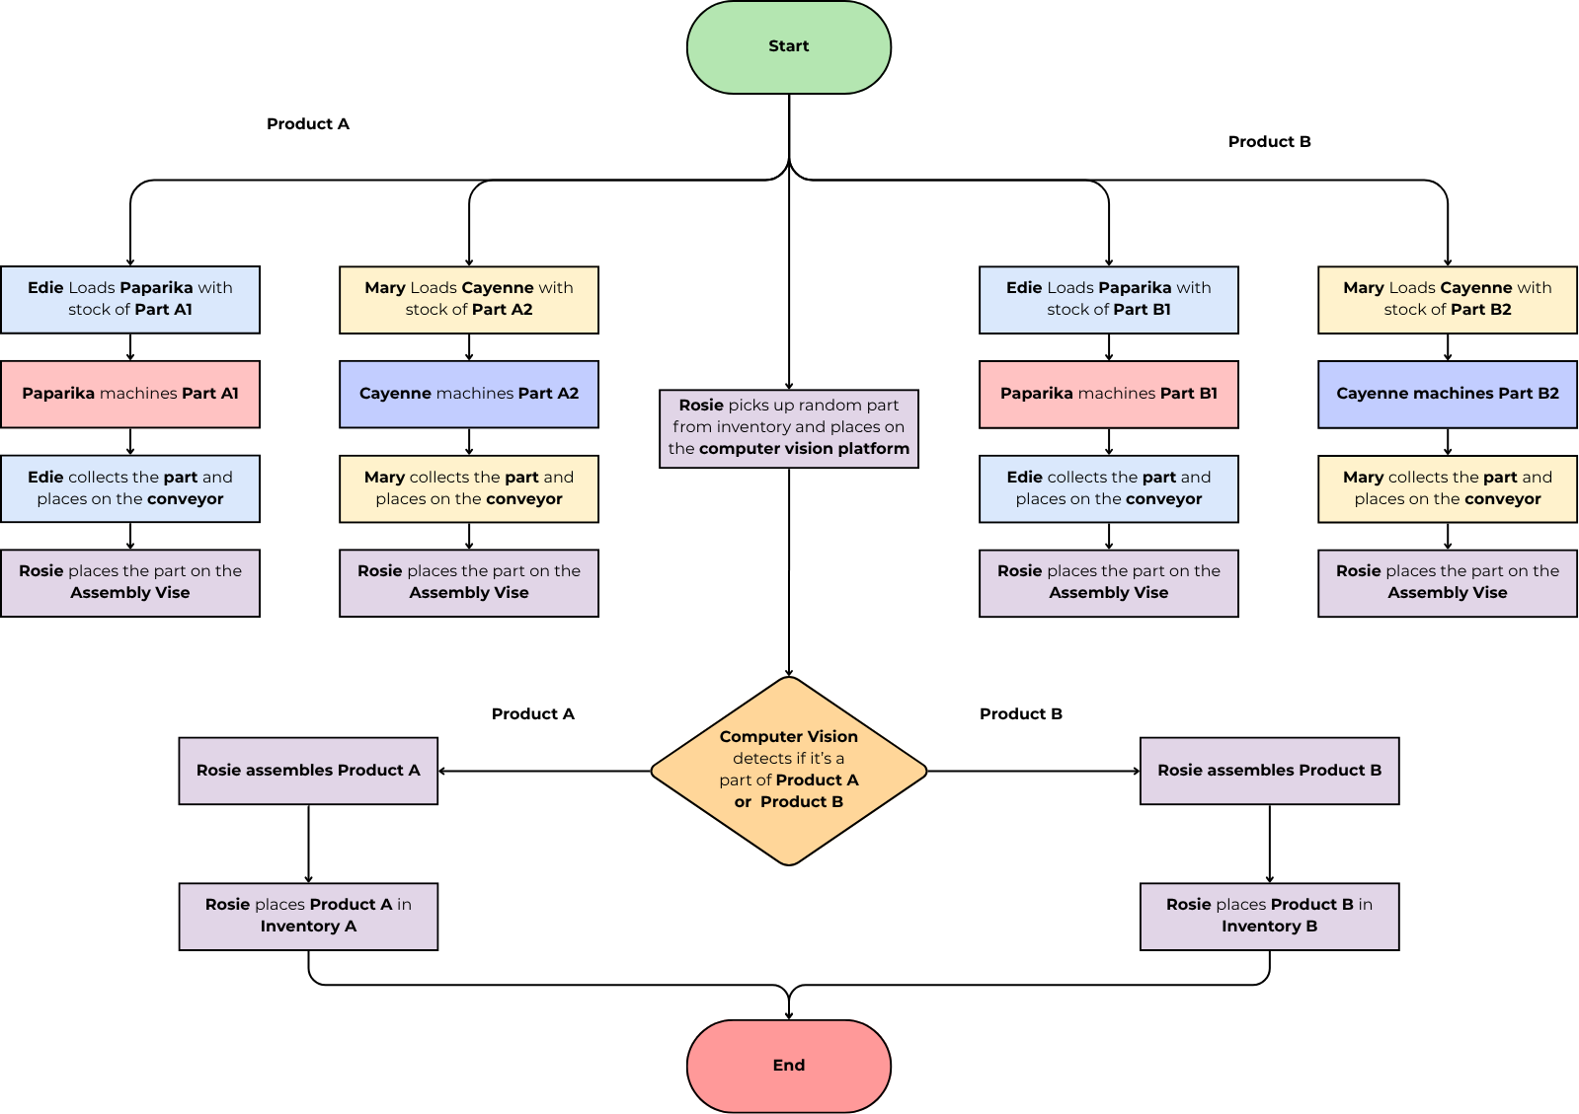

Appendix A: BUMES Script Descriptions

ShortLid:
Occurs at stations 3 (Mary, Cayenne) and 1(Rosie). Produces Lid A (short).
- Mary: loads the stock T into the cnc machine (Cayenne)
- Rosie: places pallet A on the conveyor at station 1.
- Mary: places the pallet A into InvA.
- Mary: unloads the lid ‘short’ and places it onto pallet A at InvA.
- Mary: places the pallet A on conveyer at station 3.
- Rosie: takes the pallet A with the lid ‘short’ on it and places it to InvA.

ShortBody:
Occurs at stations 4 (Edie, Paprika) and 1 (Rosie). Produces Body A (short).
- Edie: loads the stock V into the cnc machine (Paprika)
- Rosie: places pallet B on the conveyor at station 1.
- Edie: places the pallet B into InvB.
- Edie: unloads the body ‘short’ and places it onto pallet B at InvB.
- Edie: places the pallet B on conveyor at station 4.
- Rosie: takes the pallet B with the body ‘short’ on it and places it to InvB.
- Rosie: initializes the vision script and assembles it if the output of the computer vision is ‘short’.
- Rosie: places the finished product to the box.

TallLid:
Occurs at stations 3 (Mary, Cayenne) and 1(Rosie). Produces Lid B (tall).
- Mary: loads the stock T into the cnc machine (Cayenne)
- Rosie: places pallet C on the conveyor at station 1.
- Mary: places the pallet C into InvC.
- Mary: unloads the lid ‘tall’ and places it onto pallet C at InvC.
- Mary: places the pallet C on conveyer at station 3.
- Rosie: takes the pallet C with the lid ‘tall’ on it and places it to InvC.

TallBody:
Occurs at stations 4 (Edie, Paprika) and 1(Rosie). Produces Body B (tall).
- Edie: loads the stock T into the cnc machine (Paprika)
- Rosie: places pallet D on the conveyor at station 1.
- Edie: places the pallet D into InvD.
- Edie: unloads the body ‘tall’ and places it onto pallet D at InvD.
- Edie: places the pallet D on conveyor at station 4.
- Rosie: takes the pallet D with the body ‘tall’ on it and places it to InvD.
- Rosie: initializes the vision script and assembles it if the output of the computer vision is ‘tall’.
- Rosie: places the finished product to the box.

Appendix B: BUMES Script Plaintext

ShortLid
//Create a lid from raw material
//Initialize System
resourceSeize('invA')
resourceSeize('A')

startupTasksComplete()

//Collect raw material and manufacture
resourceSeize('Mary')
urDashboard('Mary', 'THU_530PM/Final/gravityFeederT.urp')
urDashboard('Mary','THU_530PM/Final/Short_StockT_LoadMill_MakePart_Tier1.urp')
resourceRelease('Mary')

startupTasksComplete()

//Move Empty Pallet to Conveyor at Station 1
resourceSeize('convStn1','agvA')
resourceSeize('Rosie')
urDashboard('Rosie','THU_530PM/_adminCG-invAToPHome.urp')
urDashboard('Rosie','THU_530PM/_adminCG-PHomeToConveyor.urp')
resourceRelease('Rosie')
resourceRelease('convStn1')

//Retrieve Empty Pallet from Conveyor at Station 3
resourceSeize('convStn3','agvA')
resourceSeize('Mary')
urDashboard('Mary','THU_530PM/_adminCG-ConveyorToPHome.urp')
urDashboard('Mary', 'THU_530PM/_adminCG-PHomeToInvA.urp')
resourceRelease('Mary')
resourceRelease('convStn3')

//Move the completed lid to the inventory, then conveyor
resourceSeize('Mary')
urDashboard('Mary','THU_530PM/Final/Short_Lid_UnloadMill.urp')
urDashboard('Mary','THU_530PM/Final/Short_PHomeToInvA.urp')
resourceRelease('Mary')
resourceSeize('convStn3','agvA')
resourceSeize('Mary')
urDashboard('Mary','THU_530PM/_adminCG-InvAtoPHome.urp')
urDashboard('Mary', 'THU_530PM/_adminCG-PHomeToConveyor.urp')
resourceRelease('Mary')
resourceRelease('convStn3')

//Send finished part to station 1
resourceSeize('convStn1','agvA')
resourceSeize('Rosie')
urDashboard('Rosie','THU_530PM/_adminCG-ConveyorToPHome.urp')
urDashboard('Rosie', 'THU_530PM/_adminCG-PHomeToInvA.urp')
resourceRelease('Rosie')
resourceRelease('convStn1')

//Wait for the corresponding body, assemble, and finish
resourceRelease('A')
resourceSeize('B')
resourceSeize('Rosie')
urDashboard('Rosie','THU_530PM/_adminCG-AssembleAToB.urp')
resourceRelease('Rosie')
resourceRelease('B')
resourceSeize('A')
resourceRelease('A')
resourceRelease('invA')

ShortBody
//Create a lid from raw material
//Initialize System
resourceSeize('invB')
resourceSeize('B')

startupTasksComplete()

//Collect raw material and manufacture
resourceSeize(Edie)
urDashboard(Edie, 'THU_530PM/Final/gravityFeederV.urp')
urDashboard(Edie,'THU_530PM/Final/Short_StockV_LoadMill_MakePart_Tier1.urp')
resourceRelease(Edie)

startupTasksComplete()

//Move Empty Pallet to Conveyor at Station 1
resourceSeize('convStn1','agvB')
resourceSeize('Rosie')
urDashboard('Rosie','THU_530PM/_adminCG-invBToPHome.urp')
urDashboard('Rosie','THU_530PM/_adminCG-PHomeToConveyor.urp')
resourceRelease('Rosie')
resourceRelease('convStn1')

//Retrieve Empty Pallet from Conveyor at Station 4
resourceSeize('convStn4','agvB')
resourceSeize(Edie)
urDashboard('Edie','THU_530PM/_adminCG-ConveyorToPHome.urp')
urDashboard('Edie', 'THU_530PM/_adminCG-PHomeToInvB.urp')
resourceRelease('Edie')
resourceRelease('convStn4')

//Move the completed lid to the inventory, then conveyor
resourceSeize('Edie')
urDashboard('Edie','THU_530PM/Final/Short_Body_UnloadMill_Tier1.urp')
urDashboard('Mary','THU_530PM/Final/Short_PHomeToInvB.urp')
resourceRelease('Edie')
resourceSeize('convStn4','agvB')
resourceSeize('Edie')
urDashboard('Edie','THU_530PM/_adminCG-InvBtoPHome.urp')
urDashboard('Edie', 'THU_530PM/_adminCG-PHomeToConveyor.urp')
resourceRelease('Edie')
resourceRelease('convStn4')

//Send finished part to station 1
resourceSeize('convStn1','agvB')
resourceSeize('Rosie')
urDashboard('Rosie','THU_530PM/_adminCG-ConveyorToPHome.urp')
urDashboard('Rosie', 'THU_530PM/_adminCG-PHomeToInvB.urp')
resourceRelease('Rosie')
resourceRelease('convStn1')

//Wait for the corresponding body, assemble, and finish
resourceRelease('B')
resourceSeize('A')
resourceSeize('Rosie')
urDashboard('Rosie','THU_530PM/Final/Short_LidToCamera.urp')
urDashboard('Rosie','THU_530PM/Final/Assembly_Vision.urp')
resourceRelease('Rosie')
resourceRelease('A')
resourceSeize('B')
resourceRelease('B')
resourceRelease('invB')

TallLid
//Create a lid from raw material
//Initialize System
resourceSeize('invC')
resourceSeize('C')

startupTasksComplete()

//Collect raw material and manufacture
resourceSeize('Mary')
urDashboard('Mary', 'THU_530PM/Final/gravityFeederT.urp')
urDashboard('Mary','THU_530PM/Final/Tall_StockT_LoadMill_MakePart_Tier3.urp')
resourceRelease('Mary')

startupTasksComplete()

//Move Empty Pallet to Conveyor at Station 1
resourceSeize('convStn1','agvC')
resourceSeize('Rosie')
urDashboard('Rosie','THU_530PM/_adminCG-invCToPHome.urp')
urDashboard('Rosie','THU_530PM/_adminCG-PHomeToConveyor.urp')
resourceRelease('Rosie')
resourceRelease('convStn1')

//Retrieve Empty Pallet from Conveyor at Station 3
resourceSeize('convStn3','agvC')
resourceSeize('Mary')
urDashboard('Mary','THU_530PM/_adminCG-ConveyorToPHome.urp')
urDashboard('Mary', 'THU_530PM/_adminCG-PHomeToInvC.urp')
resourceRelease('Mary')
resourceRelease('convStn3')

//Move the completed lid to the inventory, then conveyor
resourceSeize('Mary')
urDashboard('Mary','THU_530PM/Final/Tall_Lid_UnloadMill.urp')
urDashboard('Mary','THU_530PM/Final/Tall_PHomeToInvC.urp')
resourceRelease('Mary')
resourceSeize('convStn3','agvC')
resourceSeize('Mary')
urDashboard('Mary','THU_530PM/_adminCG-InvCtoPHome.urp')
urDashboard('Mary', 'THU_530PM/_adminCG-PHomeToConveyor.urp')
resourceRelease('Mary')
resourceRelease('convStn3')

//Send finished part to station 1
resourceSeize('convStn1','agvC')
resourceSeize('Rosie')
urDashboard('Rosie','THU_530PM/_adminCG-ConveyorToPHome.urp')
urDashboard('Rosie', 'THU_530PM/_adminCG-PHomeToInvC.urp')
resourceRelease('Rosie')
resourceRelease('convStn1')

//Wait for the corresponding body, assemble, and finish
resourceRelease('C')
resourceSeize('D')
resourceSeize('Rosie')
resourceRelease('Rosie')
resourceRelease('D')
resourceSeize('C')
resourceRelease('C')
resourceRelease('invC')

TallBody
//Create a lid from raw material
//Initialize System
resourceSeize('invD')
resourceSeize('D')

startupTasksComplete()

//Collect raw material and manufacture
resourceSeize('Edie')
urDashboard('Edie', 'THU_530PM/Final/gravityFeederV.urp')
urDashboard('Edie','THU_530PM/Final/Tall_StockV_LoadMill_MakePart_Tier3.urp')
resourceRelease('Edie')

startupTasksComplete()

//Move Empty Pallet to Conveyor at Station 1
resourceSeize('convStn1','agvD')
resourceSeize('Rosie')
urDashboard('Rosie','THU_530PM/_adminCG-invDToPHome.urp')
urDashboard('Rosie','THU_530PM/_adminCG-PHomeToConveyor.urp')
resourceRelease('Rosie')
resourceRelease('convStn1')

//Retrieve Empty Pallet from Conveyor at Station 4
resourceSeize('convStn4','agvD')
resourceSeize('Edie')
urDashboard('Edie','THU_530PM/_adminCG-ConveyorToPHome.urp')
urDashboard('Edie', 'THU_530PM/_adminCG-PHomeToInvD.urp')
resourceRelease('Edie')
resourceRelease('convStn4')

//Move the completed lid to the inventory, then conveyor
resourceSeize('Edie')
urDashboard('Edie','THU_530PM/Final/Tall_Lid_UnloadMill.urp')
urDashboard('Edie','THU_530PM/Final/Tall_PHomeToInvD.urp')
resourceRelease('Edie')
resourceSeize('convStn4','agvD')
resourceSeize('Edie')
urDashboard('Edie','THU_530PM/_adminCG-InvDtoPHome.urp')
urDashboard('Edie', 'THU_530PM/_adminCG-PHomeToConveyor.urp')
resourceRelease('Edie')
resourceRelease('convStn4')

//Send finished part to station 1
resourceSeize('convStn1','agvD')
resourceSeize('Rosie')
urDashboard('Rosie','THU_530PM/_adminCG-ConveyorToPHome.urp')
urDashboard('Rosie', 'THU_530PM/_adminCG-PHomeToInvD.urp')
resourceRelease('Rosie')
resourceRelease('convStn1')

//Wait for the corresponding body, assemble, and finish
resourceRelease('D')
resourceSeize('C')
resourceSeize('Rosie')
urDashboard('Rosie','THU_530PM/Final/Tall_LidToCamera.urp')
urDashboard('Rosie','THU_530PM/Final/Assembly_Vision.urp')
resourceRelease('Rosie')
resourceRelease('C')
resourceSeize('D')
resourceRelease('D')
resourceRelease('invD')

